linear_models_external_data.R

Tue May 9 21:10:21 2017

#Load data from external source via download  
data("women")  
  
#Take a peak of women data set  
head(women)

## height weight  
## 1 58 115  
## 2 59 117  
## 3 60 120  
## 4 61 123  
## 5 62 126  
## 6 63 129

#Correlation of the women: height vs weight  
cor(women$height, women$weight)

## [1] 0.9954948

#Correlation is 0.9954 this is indeed a strong linear model, due to the correlation value so close to 1.0  
  
#Quick scatter plot  
plot(women$weight,women$height)

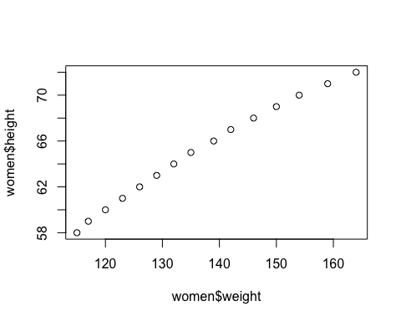

#Load data from external source via download  
data("cars")  
  
#Take a peak of car data set  
head(cars)

## speed dist  
## 1 4 2  
## 2 4 10  
## 3 7 4  
## 4 7 22  
## 5 8 16  
## 6 9 10

#Correlation of the cars: speed vs weight  
cor(cars$speed, cars$dist)

## [1] 0.8068949

#Correlation is 0.8068 this is mild linear model, due to the correlation value is < 1.0, but there is a relationship.  
plot(cars$speed, cars$dist)

